Sai Kiran Reddy Kotha

# Banner 700746206

Link:

## <https://drive.google.com/file/d/1qe828APPGYQwurC_EK16CMR5R5XGZwMf/view?usp=share_link>

https://github.com/reddysahib/assignment_ml

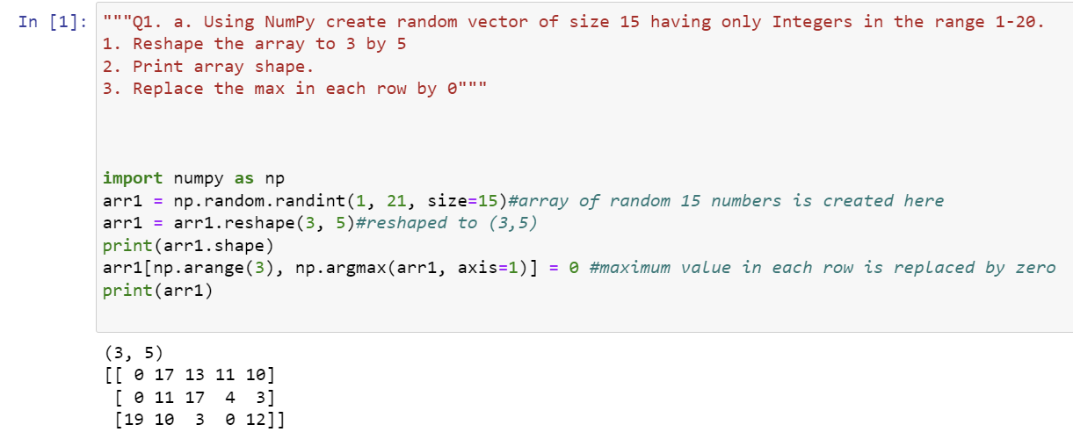

np.random.randint(1, 21, size=15) creates array of size 15 with numbers between 1 and 20.

This code creates a 3x5 NumPy array named arr1 with random integer values between 1 and 20 using the np.random.randint() function. Then, the shape of the array is shaped by .reshape()

arr1[np.arange(3), np.argmax(arr1, axis=1)] = 0 replaces the maximum value in each row of arr1 with 0 .The np.argmax() function is used to find the index of the maximum value in each row, and np.arange(3) is used to generate an array of row indices to index the first axis of arr1. This effectively selects the maximum value in each row.

np.array([[1, 2, 3], [4, 5, 6], [7, 8, 9], [10, 11, 12]], dtype=np.int32) creates a 2D NumPy array named arr1 with shape 4x3 and 4-byte integer elements using the np.array() function.

eigenval, eigenvect = np.linalg.eig(arr2) is the direct formula

np.trace() will compute the sum of arr3 diagonal elements. We then print the sum.

.reshape() method is used to reshape the array to a 2x3 array.

Then, the plt.pie() function is used to create the pie chart. The popularity list is passed in as the data to be plotted, and the labels parameter is used to provide the names of the programming languages. The autopct parameter specifies that the percentage values for each slice of the pie should be displayed with one decimal place.